Online Discussions
Dr. Marsha Fralick

Discussion: Introduce Yourself to the Class
Please create a short introductory video. Just click on Reply at the bottom of the page and then the video icon to create your video. If your computer does not have a camera, create the video on your cell phone. See my short video below.

You can be creative on your video. Just keep it respectful. If you are wondering what to say, here are some ideas:
Why are you taking this course?
What are some of your future goals?
What do you do for fun outside of class?
Can you add some music or artwork to your video?
Do you have a pet you can show?

Watch other students' videos and reply to at least 2 of them.

Chapter 1: Motivation
It was great meeting you on the discussion board last week and learning about your goals for the future. We have a great variety of students in the class and many different educational backgrounds. This diversity makes for interesting discussion and sharing of ideas.
For this week, share your ideas on motivation with other students in this course. Read other student comments and reply to at least two of them to receive full credit for the discussion.
Please read Chapter 1 in College and Career Success Online before commenting on any of these questions.
Postings for this week are due before 11:59 p.m. on Sunday. You can choose to write on any of these questions.
- How do you motivate yourself to be successful?
- Are there some new ideas on motivation in Chapter 1 that you find interesting or helpful?
- If you are thinking about dropping this class or dropping out of college, how can you motivate yourself to continue?
- What are some roadblocks to your success and how can you overcome them?
- Read comments posted by other students. Are any of their ideas useful to you?
- You can also write about your experience in beginning college or starting this course.
- Comment on this video about living your dream and having no regrets:
https://www.youtube.com/watch?v=aiA3gtAybmc&t=4s
Chapter 2: Personality and Major
I was inspired reading all your blog posts on motivation. Motivation sets the stage for success. Many of you mentioned careers and the economy as motivators for going to college. You are more likely to be employed and to like your career if you have an education. One of the keys to success is what you do on a daily basis, so do a little of your homework each day and it all adds up to success.
Chapter 2 began with the AchieveWorks Personality assessment which has a 4 letter code used to summarize your personality type based on your answers in the assessment. For example, my code is ISTJ which stands for introvert, sensing, thinking and judging type.
Posting 1:
My Personal Strengths Word Cloud.docx
Use the above file to create a Word Cloud of your personal strengths based on your personality assessment results. Begin your discussion by inserting your Word Cloud. Choose one of your letters and write 100 words about this aspect of your personality focusing on the positives of your type. Remember that one personality type is not better than any other. Each type has different talents that can be useful in your personal or career life. You may think that you are a combination of 2 different types. It is OK to describe your unique combination.

Here is a sample of my Word Cloud and about 100 words:
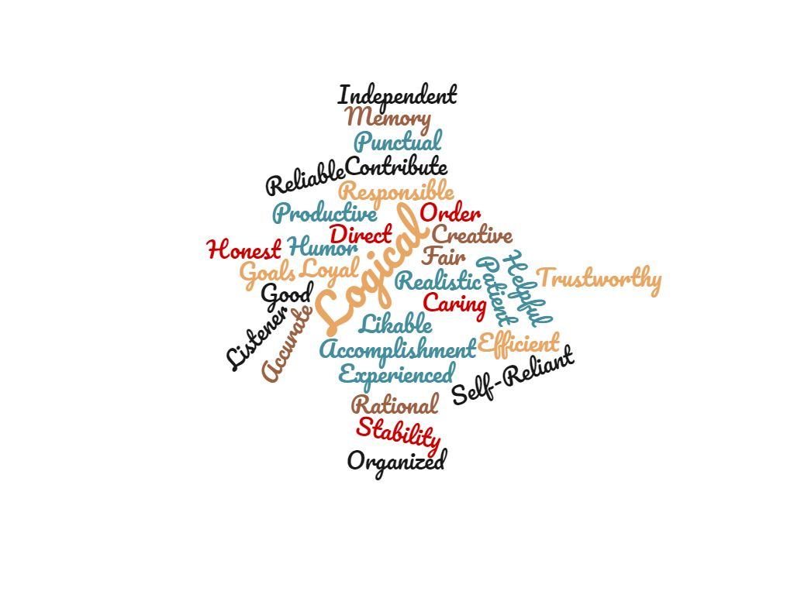

Here is a sample of about 100 words:
Based on the AchieveWorks Personality assessment, I am a judging type which means that I prefer to be orderly and organized. I know that this is true because I can only feel relaxed when things are orderly and organized. I plan my work and think about priorities when managing my time which helps me to accomplish my goals. I even plan out my vacations in advance and like to have everything planned so I can relax and have fun. I have met some opposite types in my lifetime and try to appreciate their differences. I have found that perceptive types can usually introduce an element of fun in the situation and they motivate me to be a little more spontaneous at times. I’m still most comfortable with my plans and don’t like to change them.

Replies:
Read other student’s postings who have the same personality type as yours and write a response to two other students.
Here is a sample response of about 100 words:
I am a judging type also. I could relate to your need to be orderly and organized. I generally plan my time and like to have all my things organized. I get stressed when things are out of order. I have also met some perceptive types and I have to admit that they drive me a little crazy. I like your idea of appreciating their differences and just trying to have fun with them. I know that these opposite types think I am too set in my ways. Being a judging type has lots of positives. I plan to major in accounting and this seems to be a natural fit for my personal strengths.

Just as a quick review, here is a brief definition of all types on AchieveWorks Personality assessment. Please review these definitions before you make your comments.
(I) Introvert: private, likes quiet for concentration, likes to think before speaking
(E) Extravert: social, likes variety, sometimes speaks before thinking
(S) Sensing: works step-by-step, learns from experience, trusts what is concrete and certain
(N) Intuitive: values imagination and innovation, focus on possibilities, creative and imaginative
(T) Thinking: calm and objective, makes decisions based on logic, analyzes emotions, likes debate
(F) Feeling: makes decisions based on personal values, values empathy and harmony, caring, emotional
(J) Judging: orderly, organized, work first and play later, follows a routine, meets deadlines (Note: it does not mean to judge others!)
(P) Perceptive: spontaneous, go with the flow, play first and do the work later, dislike routine, difficulty meeting deadlines

Chapter 3: Multiple Intelligences, Interests, and Values
For this week, write 200 words on one or more topics below and reply to at least two students.
What are your highest multiple intelligences and what careers do they suggest?
Write about your experiences in college so far. Have you been able to apply anything learned in this class?
What is your most important value in life and how are you acting on this value to achieve your life goals?
Comment on a successful decision you have made and how it matches your values.
Comment on an unsuccessful decision you made and how it did not match your values.
What are your highest interests as described by the Interest Profiler in this chapter? How do these interests match your career choice or the major you are considering? Interests include realistic, investigative, artistic, social, enterprising and conventional.
Comment on other students’ posts. Can you add to their comment or raise new questions?
As one of your options this week, you can comment on one of the scenarios below. Based on the individual’s values, give your opinion about what would be the best decision.
Scenario 1: What should be my major?
Shawn is twenty years old and has completed two years of college. He has been trying to decide whether to major in engineering or music. He has completed all of his general education requirements as well as several courses in music, math, and physics. As a child, Shawn was interested in science and dreamed of making new inventions. He always took things apart to see how they worked. Math was always easy for Shawn, and he received awards for achievement in science. He also took part in band throughout his school years and learned to play several instruments. As a teenager, he had a garage band and became so interested in playing the piano that he spent two hours a day practicing. Shawn’s dilemma was that he was becoming stressed out trying to do both majors and
no longer had time to do well in both music and engineering. He also wanted to have time to get a part-time job in order to become more independent. Shawn’s top five values are being independent and living on his own, having a secure future, doing interesting work, achieving something important, and being able to relax. Based on his values, what major should Shawn choose?
Scenario 2: Should Maria continue her education?
Maria is a married mother of two young boys ages five and seven and a part-time college student. Maria and her husband, Juan, are very proud of their Mexican heritage and value their marriage and family. They both think that it is important for Maria to spend time with the children. Maria learned to speak English as a second language and has made sure that her children speak both English and Spanish. While the children are in school, Maria has been attending college part-time with the goal of becoming a teacher’s aide in a class for bilingual children. She has some experience as a teacher’s aide and gets a great deal of satisfaction from helping the children. Juan works in construction, and the family has sacrificed to come up with the money to pay for Maria to attend college. Maria has struggled to earn her associate’s degree and is proud of her accomplishments. She values her education and wants her children to do well in school. Now Maria is considering continuing her education to earn the bachelor’s degree so that she can become a teacher. She would enjoy having her own classroom, loves working with children, and would have a higher income as a teacher than she would as a teacher’s aide. Maria’s husband is concerned that she will spend too much time at college and will not be home for the children. He is also relieved that Maria has finished college and plans to work part-time to supplement the family income while the children are in school. Should Maria continue her education and earn a bachelor’s degree?

Chapter 4: Planning Your Career and Education
The chapter for this week is "Planning your Career and Education." It has some useful information as you think about your future career. You have begun the process of understanding your personal strengths, interests and talents. The next step is to match your characteristics to the world of work. It is important to understand the job outlook so that you will know about job availability and pay. Note that your career portfolio includes indeed.com which is a site where you can look up current jobs in your area of interest to see how many jobs are available and how much they pay. You can use your career portfolio and this site to find a job when you graduate.
Choose any topic below. You can choose 2 topics of 100 words each or one topic of 200 words. Read other student comments and reply to at least two students to get full credit for this discussion.

Go to http://www.indeed.com/ (Links to an external site.) and look up some jobs that could be a match for your interests and talents. What did you discover at this site?
Go to www.assist.org (Links to an external site.) and explore this site. This site is designed to help you understand the courses needed to transfer to a four-year university. Share with the group what you found there.
Go to http://www.cuyamaca.edu/transfer_center (Links to an external site.) and explore this site. This is our Cuyamaca College Transfer site. Share with the group what you found at this site.
Add your comment to another student's posting. Can you relate to what they are saying, and can you share similar experiences?
What is your generation? Baby Boomer? Generation X? New Millennial? Generation Z? How will your generation affect your future career choices?
Review the employment trends presented in the career chapter. How will these employment trends affect your future career plans?
What tips would you give to a friend before he or she interviewed for a job that was really important?

Chapter 5: Managing Time and Money
This new chapter is about time management and is one of the most powerful chapters in the text. For this week's discussion, share one of your lifetime goals and describe the time management techniques you will use to accomplish this goal. If there are obstacles in the way, how will you deal with them?
Do you get distracted by technology? Does your phone, the Internet, or video games get in the way of accomplishing important goals or getting enough sleep? If so, watch this video and comment on it.
How to Stop Your Technology Addiction
https://www.youtube.com/watch?v=pjgngyfxIzM
Sometimes it is helpful to read about other students' goals and how they are managing to accomplish them. Read other students' posts and reply to two of them.
Here is my post which is 276 words:
I will share with you one of my lifetime goals and how I used the ideas in this chapter to accomplish it. My lifetime goal was to write a book on how to be successful in college because I struggled as a young college student and learned how to be successful. Then I taught the topic for 30 years. I had some time off from work and set as my goal to write the text. I found myself distracted by things around the home. I would get up in the morning and exercise, make myself a nice breakfast, read the paper and do a few household chores. Soon the day was gone and I had not accomplished my goal. I decided to work on my goal first and then reward myself with exercise and other things that I wanted to do. It was just a matter of rearranging my tasks. I still found it difficult to get started. I used the idea of a leading task. I would just sit at the computer, fill my head with ideas and start to write. Then I would refine the writing the next day. Within 6 months I had the first draft of the text written. Today it is used in about 80 colleges across the country. This new edition of College and Career Success Online is my latest project.
Ok, I have shared one of my goals and how I accomplished it. Now it is your turn. Tell about something you accomplished in the past or something you hope to accomplish in the future. See if you can use some of the time management ideas in the text.

Chapter 6: Using Brain Science to Improve Memory
For this chapter, watch one of these videos and write a 100-word comment including what you like, dislike, or find useful.
For the second posting, read 2 other students’ comments and add you own thoughts, goals for the future, or ideas for using the information to improve your memory and study skills.
Here are the links to the video choices:
The Nine Best Scientific Study Skills
https://www.youtube.com/watch?v=p60rN9JEapg
Sleep to Remember, Remember to Sleep
https://ed.ted.com/lessons/the-benefits-of-a-good-night-s-sleep-shai-marcu?utm_source=TED-Ed+Subscribers&utm_campaign=ecd56a0428-2013_09_219_19_2013&utm_medium=email&utm_term=0_1aaccced48-ecd56a0428-43155577
Sorry, You’re Addicted to the Internet
https://www.youtube.com/watch?v=NpluiONwJLg
How to Study Effectively with 15 Study Tips: Better Grades, Better Results
https://www.youtube.com/watch?v=Qx48xClXJq8
How to Get Straight A’s Study Tips
https://www.youtube.com/watch?v=Ih3QUZciZls
Study Hacks! Get Better Grades
https://www.youtube.com/watch?v=rc9dpAphbRU

Chapter 7: Using Brain Science to Improve Study Skills
One of the key concepts in this chapter is that we use all the senses to learn, a process called multi-sensory integration. Of all the senses, visualization is the most powerful.
Think about how you can use multiple senses (visual, auditory, tactile, kinesthetic, gustatory, olfactory) to be successful in challenging material in your present courses or think about one of the scenarios below and apply this concept to being successful in one of these situations. Your post should be at least 100 words.
You can also comment on one of these scenarios.
- You just read the assigned chapter in economics and cannot remember what you read. It went in one ear and out the other.
- In your anatomy and physiology class, you are required to remember the scientific name for 100 different muscles in the body.
- You signed up for a philosophy class because it meets general education requirements. You are not interested in the class at all.
- You have a mid-term in your literature class and have to read 400 pages in one month.
- You must take American history to graduate from SDSU. You think that history is boring.
- You have been introduced to an important business contact and would like to remember his/her name.
- You are enrolled in an algebra class. You continually remind yourself that you have never been good at math. You don’t think that you will pass this class.
- You are taking a math course that you need for graduation and don’t understand some of the math problems. You are worried that you may not pass this course.
Read what other students are saying and reply to two of them.

Chapter 8 Taking Notes, Writing, and Speaking
This week read the chapter on taking notes, writing and speaking and then write a minimum of 100 words on any of these topics. Then reply to two other students.
Here are the options for your discussion:
Watch any of these videos and tell what interesting or useful ideas you have discovered:
Free Writing
https://www.youtube.com/watch?v=4O0EMX0nnl4
This is a technique for coming up with ideas for any writing project.

Five Basic Public Speaking Tips
https://www.youtube.com/watch?v=AykYRO5d_lI
Here are five tips from Toastmasters that would be helpful in delivering any speech.

The Science of Stage Fright and How to Overcome It
https://ed.ted.com/lessons/the-science-of-stage-fright-and-how-to-overcome-it-mikael-cho
This is a TED talk on how to overcome stage fright or fear of public speaking.

The Cornell Notes Slideshow
https://www.youtube.com/watch?v=U-FCogxQFHI&list=PLBD6F24944B69A5DA&context=C4f0b1aaADvjVQa1PpcFOdLICi2Pt5lC2cPmlVcoEJvAS5dE364xg%3D
This 40 second video explains how to take notes in the Cornell format.

How to Make a Mind Map
https://www.youtube.com/watch?v=wLWV0XN7K1g&feature=autoplay&list=PLBD6F24944B69A5DA&playnext=1
This video shows the steps in creating a mind map for taking notes or studying for tests.

What is the meaning of this quote by William James?
“The essence of genius is knowing what to overlook.”

How can you take steps toward being a genius by being selective at school, at work or in your personal life?
Write some intention statements about what you will do to become a better writer or note taker.
Remember to make a comment on 2 other students’ posts.

Chapter 9: Test Taking
Please read the chapter on test taking and write a minimum of 100 words on any of these topics. Then reply to 2 other students. Here are the options for your discussion:

- Students often say, “I am not a good test taker.” What ideas in this chapter would be helpful to this student?

- Look at this YouTube video, "Test Stress Reduction the Navy Seals Way." This 3 minute video shows some ways to be successful “when the world is on fire.” Can the Navy Seals techniques be used in college and in life in general?
https://www.youtube.com/watch?v=0S9YsqERT34
- If you have difficulties with text anxiety, take a look at this video and summarize the key points:
https://www.youtube.com/watch?v=PQd1QpiSLhM

- How do you study for a math test?

- What is the ideal way to review for a test?

- What are some disadvantages of cramming for a test and how can you avoid cramming?

- What is your best idea for studying for exams?

Remember to comment on 2 other students’ posts.

Chapter 10: Communication and Relationships
The chapter on communication provided some ideas for improving communication. Are any of these ideas helpful to you? Write a minimum of 100 words on any topic below. Then reply to two other students.

You can describe how you plan to apply some of the ideas in this chapter to improving communication with your children, boss, friends or parents or anyone who is important in your life.
What is your personality type and how does it affect your personal communication style?

Comment on this TED talk video, “Lessons from Auschwitz, The Power of Our Words

https://ed.ted.com/lessons/lessons-from-auschwitz-the-power-of-our-words-benjamin-zander?utm_source=TED-Ed+Subscribers&utm_campaign=692caa8df5-2013_09_219_19_2013&utm_medium=email&utm_term=0_1aaccced48-692caa8df5-43155577
The central message is that our words are powerful, and we never know when our words are the last ones a person will hear from us.

Comment on these videos:

Michael Jordan on Failure
https://www.youtube.com/watch?v=45mMioJ5szc

Famous Failures
https://www.youtube.com/watch?v=zLYECIjmnQs

Comment on this video: Finish Strong
https://www.youtube.com/watch?v=iVDizl38U24
It is about a man born with no arms or legs and how he overcomes life’s obstacles.

You can also read the scenarios below and use your knowledge of personality type to suggest ways to improve the communication. For a quick review of personality type, click on AchieveWORKS Personality assessment on the front page of your portfolio on College and Career Success Online. You can comment on one or more of the scenarios. Remember to think about personality type and how it influences communication as you write your comments.

Scenario 1 (E and I):
Mary and Carol are roommates and are discussing paying bills for the apartment that they share. Mary is upset because Carol paid the phone bill late. The more that Mary talks, the quieter Carol becomes. This causes Mary to become even more upset. Mary starts talking in a loud voice and Carol leaves the room. How can they improve communication?

Scenario 2 (S and N):
A sensing type and an intuitive type are on a first date. What is each likely to talk about?
Scenario 3 (T and F):
Rachel and Jim have been married about a year. Rachel complains to Jim that he never says, "I love you" anymore. Jim replies that he would not have married Rachel if he didn't love her. How can they improve communication?
Scenario 4 (J and P):
Students in a business class are assigned as a group project to design a business plan. This is an evening class and has mostly adults who have busy schedules with work, family and school. Mike is a highly motivated student who wants to get the group organized and complete the project quickly. Mike is getting irritated at John because he cannot decide on a topic and get going. John keeps coming up with different creative ideas for the business plan. John is getting irritated at Mike because he thinks that Mike is trying to control the group. How can this group work together to complete a successful project?

Chapter 11: Thinking Critically and Creatively
For this discussion, please comment on these 2 topics:
For the first post, give an example of a fallacy in reasoning from commercials, politics, or your own personal life. Here are some examples.
When my children were very young, I would tell them to brush their teeth in the evening. I told them that if they did not brush their teeth, the sugar bugs would eat their teeth all night and eventually their teeth would turn green and fall out. By predicting dire consequences, we try to influence behavior. This is an example of using slippery slope. Maybe some of you child development majors would have a better way of getting children to brush their teeth, but this worked for me.
When my daughter was in middle school, she died her blond hair black. I asked her why she did it and she said that she was tired of blond jokes. She was the victim of the stereotype that all blondes are dumb.
You will also find many examples of fallacies in reasoning in commercials. Take this supplement, eat what you want, don't exercise, and lose weight. Buy this expensive cream and you will look younger.
Here are just a couple of recent examples of fallacies in reasoning in politics: all refugees are terrorists; all Mexicans are criminals.

For your second post, respond to this creative thinking exercise.
Review the information on creativity and brainstorming and have a little fun with this exercise. Provide at least 3 answers to these questions:

How is a peanut like you? Here are my answers.
- A peanut is wrinkled, like me.
- A peanut is curvy like me.
- I have a hard outer shell and a soft inner shell.

How is a peanut like going to college?
- In every classroom there are at least 2 nuts, the instructor and at least one student.
- The squares on the peanut remind me of rows of chairs in the classroom.
- There is usually something good on the inside.
Read other students’ posts and reply to at least two of them. You can provide feedback on their creative peanut answers.

Chapter 12: Maintaining a Healthy Lifestyle
Chapter 12 contains health information for college students in the areas of nutrition, avoiding addictions, protection from disease, getting enough sleep, and dealing with stress. It is based on the premise that we will be living longer in the 21st Century. Also a college education is a big investment and it is important to enjoy the benefits over a long lifetime.
Here are some ideas for discussion. Reply to any of these topics in 100 words. Remember to read other students' comments and respond to at least two of them to get full credit for this discussion.
These facts are well known:
• Smoking causes lung cancer.
• One out of three Americans is overweight or obese.
• Illegal drug use is addictive and limits success.
• Not getting enough sleep is harmful to health and learning.
• Not practicing monogamous or safe sex can lead to STD’s including AIDS.
Knowing this information, why do people continue to smoke, overeat, take illegal drugs, miss out on sleep or practice unsafe sex?
Assume that you are writing magazine article, "The Five Most Important Steps to Maintaining Your Good Health." What ideas would you include in this article?

Share some of your intention statements for maintaining your good health.

Watch any of these videos and make a comment about one of them:
Jaime Oliver: Teach Every Child about Food
https://www.ted.com/talks/jamie_oliver_teach_every_child_about_food
Know the Dangers of Not Getting Enough Sleep
https://www.youtube.com/watch?v=kXRCK-8YIF0
How to Make Stress Your Friend
https://www.youtube.com/watch?v=RcGyVTAoXEU&feature=em-subs_digest
Sleep to Remember, Remember to Sleep
https://ed.ted.com/lessons/the-benefits-of-a-good-night-s-sleep-shai-marcu?utm_source=TED-Ed+Subscribers&utm_campaign=ecd56a0428-2013_09_219_19_2013&utm_medium=email&utm_term=0_1aaccced48-ecd56a0428-43155577
I wish all of you good health!

Chapter 13: Appreciating Diversity
One of the most exciting scientific accomplishments of this century is Human Genome Project which is the cataloging of human genes. This will lead to great understanding of the human body and advance medical science. One of the most important findings is that while human beings differ in outward appearance, the genetic structure of all human beings is 99.9% identical. These researchers agree that there is only one race, the human race.
However, we continue to struggle with the concept of appreciating diversity, and discrimination and prejudice still exist in many forms. For example, you may have been discriminated against because of your ethnic group, religion, height, weight, gender, disability, or even academic skills. For this discussion, give an example of a circumstance where you have experienced or witnessed discrimination. Any ideas on how to reduce discrimination?
I will share an example of discrimination that I experienced. I started my doctoral program at USC when I was 8 months pregnant. After the first class the professor took me aside and suggested that I drop out of the program because of my family situation. I was really angry and decided to show him that I would finish. I am happy to report that I was one of the first three students to finish the program. Since I had a family, I had no time to waste.
At Cuyamaca College, we have many Chaldean students who are Christians and have emigrated from Iraq to avoid religious persecution. Since the attacks of 9-11, this group has faced discrimination at our college and in our community. Whenever there is anything about terrorism in the news, many students who are from the Middle East suffer discrimination even though they have nothing to do with terrorism. Any comments on this?
Write at least 100 words on any of the topics above. Remember to read other students’ comments and reply to at least two of them to receive full credit.

Chapter 14: Thinking Positively about the Future
Over the years of my working with students, one of the lifetime goals most mentioned is "happiness." I'm not sure if we know what happiness is or when we have accomplished this goal. I just read a book on the topic, Authentic Happiness, by Martin Seligman. He is a psychologist who actually teaches college courses on this topic. The following are some excerpts from his text. Please read these excerpts, think about them and add your comments.
Excerpts from Authentic Happiness by Martin Seligman:
Real happiness comes from identifying, cultivating and using your personal strengths in work, love, play and parenting. Seligman contrasts happiness with hedonism. He says that a hedonist "wants as many good moments and as few bad moments as possible in life." He states that hedonism is a shortcut to happiness that leaves us feeling empty. For example, we often assume that more material possessions will make us happy. However, the more material possessions we have, the greater the expectations and we no longer appreciate what we have.
Seligman suggests some ideas to increase happiness. 1. Realize that the past does not determine your future. The future is open to possibilities. 2. Be grateful for the good events of the past and place less emphasis on the bad events. 3. Build positive emotions through forgiving and forgetting. 4. Work on increasing optimism and hope for the future. 5. Find out what activities make you happy and engage in them. Spread these activities out over time so that you will not get tired of them. 6. Take the time to savor the happy times. 7. Take time to enjoy the present moment. 8. Build more flow into your life. Flow is the state of gratification we feel when totally absorbed in an activity that matches our strengths.
Write at least 100 words on any of the ideas above. What does happiness mean to you? Share some of your intention statements for the future.
Read other students’ comments and reply to at least two of them.
Your postings have been inspiring and awesome. Best wishes for the future!

Final Project
For this discussion, create a Vision Board and write a 50-word statement of your personal philosophy.
Here are some items to consider in thinking about your Vision Board and personal philosophy: positive thinking, growth mindset, passions, interests, personal strengths, multiple intelligences, self-confidence, life's purpose, personal values, lifetime goals, family, friends, achieving happiness in life, staying healthy, honesty, doing good for others, preserving the environment, spirituality.
A Vision Board contains a visual representation of your future goals and what you want to achieve in life. For directions on how to create a Vision Board, go to https://careertrend.com/how-5977631-create-goals-poster.html Take a photo of your poster and insert it into the discussion window. Here is an example of a Vision Board:
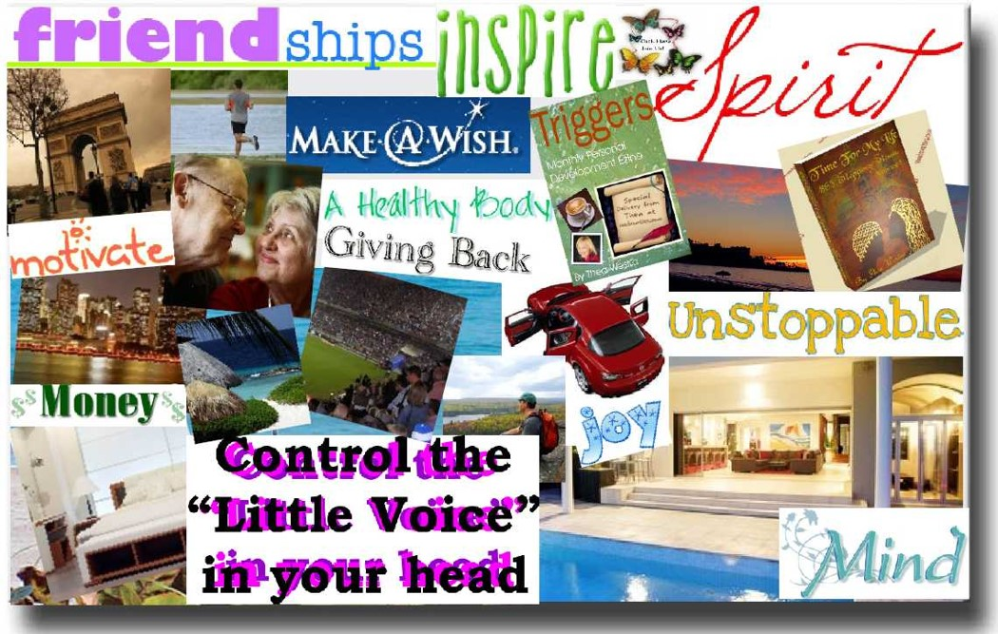

Next, add your 50 word statement of your personal philosophy. Since this statement is only 50 words, challenge yourself to think about what is most important in your life.
Your personal philosophy is a statement about how you will live the best life possible. It is the road map for achieving your goals in life. In writing your personal philosophy, think about what is important in your life and what you believe is possible. It includes your beliefs, values, attitudes, and hopes for the future. It is your plan for becoming the best you can be. It also includes staying healthy over a lifetime. This statement is valuable for two reasons:
1. It helps you to deal with changes and challenges in life and accomplish your goals.
2. It helps you to manage your time and keep yourself moving in the right direction. Ask yourself, "Will my actions in the present moment match my personal philosophy?"
Here is an example of my personal philosophy of life in 50 words:
I appreciate every day the gifts I have been given, including my intelligences, good health, and family. My purpose is to leave the world and the people in it in better condition because I existed. I enjoy seeing the world, loving my family, challenging my potential, and facing each day with a positive attitude.
For the second part of the discussion, find two other student's posts that you like and state why you like them and provide positive feedback.
Course Evaluation
Our last online assignment is to evaluate your own progress in this course and also evaluate this class and the instructor. You will be graded on simply completing the assignment and not on your comments. Your evaluation of this class is important to me so that I can improve this class in the future. You can write anything you want or use the following questions as a guide or to get ideas about what to write. Your post should be at least 200 words. I appreciate all of your comments. It was great having each one of you in my class this semester.

- Complete the Post Test on College and Career Success Online. It is located after Chapter 14. Look at your results and comment on the progress you made in this course.
- Please tell what you liked about this class and how it was useful to you.
- Do you have any suggestions for improving the class?
- What is your evaluation of our e-text, College and Career Success Online?
- What do you think about my video introductions to each chapter?
- What is your evaluation of the personality assessment, AchieveWORKS Personality (Introvert, Extravert, Sensing, Intuitive, Thinking, Feeling, Judging, and Perceptive)?
- What is your evaluation of the AchieveWORKS Intelligences assessment? The purpose of this assessment is to help students think positively about their strengths (Musical, Interpersonal, Intrapersonal, Logical-Mathematical, Spatial, Bodily-Kinesthetic, Linguistic, Naturalist and Existential). This assessment matched your personal strengths to careers. Did you find it useful?
- What is your evaluation of the AchieveWORKS Learning and Productivity assessment?
- Was this class helpful learning about yourself in order to choose a major or confirm your choice of a major?
- Did this class improve your chances for success in college?
- What is your overall evaluation of this class? (Outstanding, excellent, satisfactory, or needs improvement)
- Please rate the instructor (me). What was good and what could be improved?

